Parthenogenesis in haplodiploids

**Frequency of parthenogenesis in different taxa**

Table. Cases of parthenogenesis in haplodiploid taxa.

|  |  |  |  |  |
| --- | --- | --- | --- | --- |
| Orders | Cases | Total species | Proportion | Reference total species |
| Astigmata | 3 | 5000 | 0.001 | Norton et al 1993 |
| **Coleoptera | 2 | 350000 | 0.000 | Mayhew 2007 |
| **Hemiptera | 8 | 90000 | 0.000 | Mayhew 2007 |
| Hymenoptera | 612 | 150000 | 0.004 | Mayhew 2007 |
| Mesostigmata | 43 | 5000 | 0.009 | Norton et al 1993 |
| Ploima | 1* |  |  |  |
| Prostigmata | 6 | 14000 | 0.000 | Norton et al 1993 |
| Thysanoptera | 46 | 5000 | 0.009 | Mayhew 2007 |
| Trombidiformes | 26 | 25000 | 0.001 | Zhang et al 2011 |

*This is the Brachionus calyciflorus case by Stelzer. Ploima taxonomy under debate.

**Maybe a better way to show it at the lines where haplodiploidy evolved, but his requires some more digging.

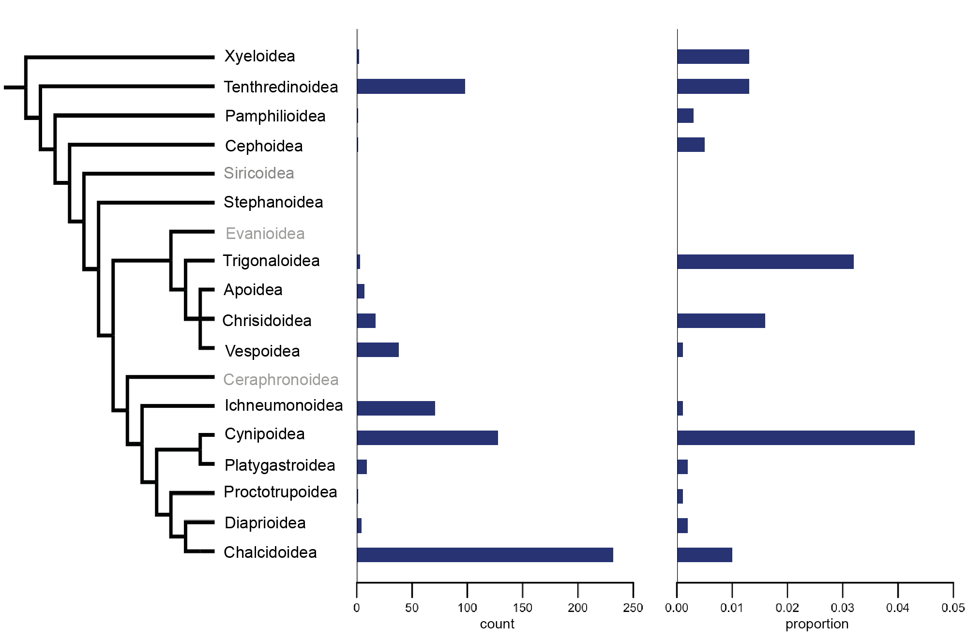

Frequency of parthenogenesis in Hymenoptera superfamilies. Phylogeny from Klopfstein et al 2013. Grey branch labels means taxa are poorly studied. Taxa with less than 80 known species were excluded (note: this saves three taxa with zero parthenogens).

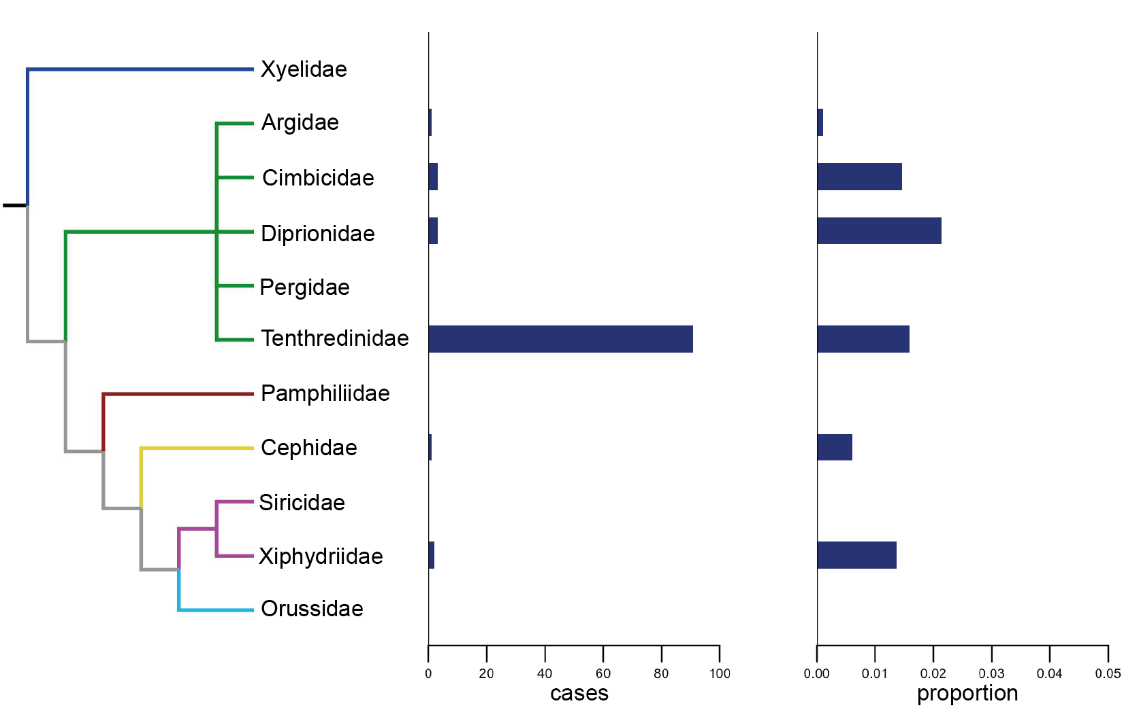

Frequency of parthenogenesis in Symphyta. Phylogeny from Klopfstein et al 2013. Different branch colors mean the families belong to different super families. Total number of species from Taeger and Blank’s database http://www.sdei.de/ecatsym/ecat_statistik.php. Families with less than 80 species documented in total were excluded (because this saves 14 branches with zero’s).

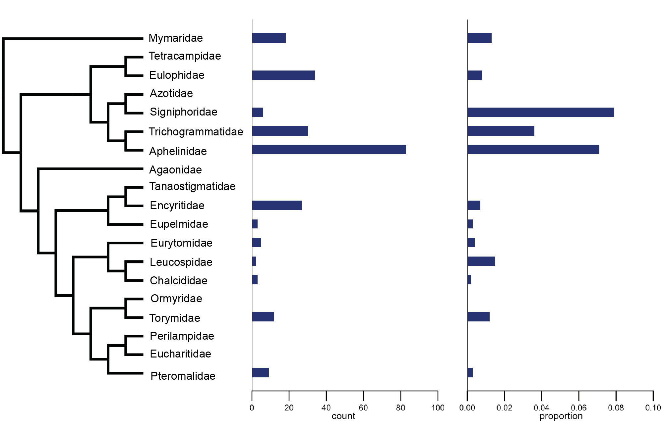

Frequency of parthenogenesis in Chalcidoidea. Phylogeny from Klopfstein et al 2013 Only families with more than 25 species described are shown (excluding three mini-families). Total number of species per family from Noyes’ Chalcidoidea database 2016 http://www.nhm.ac.uk/our-science/data/chalcidoids/.

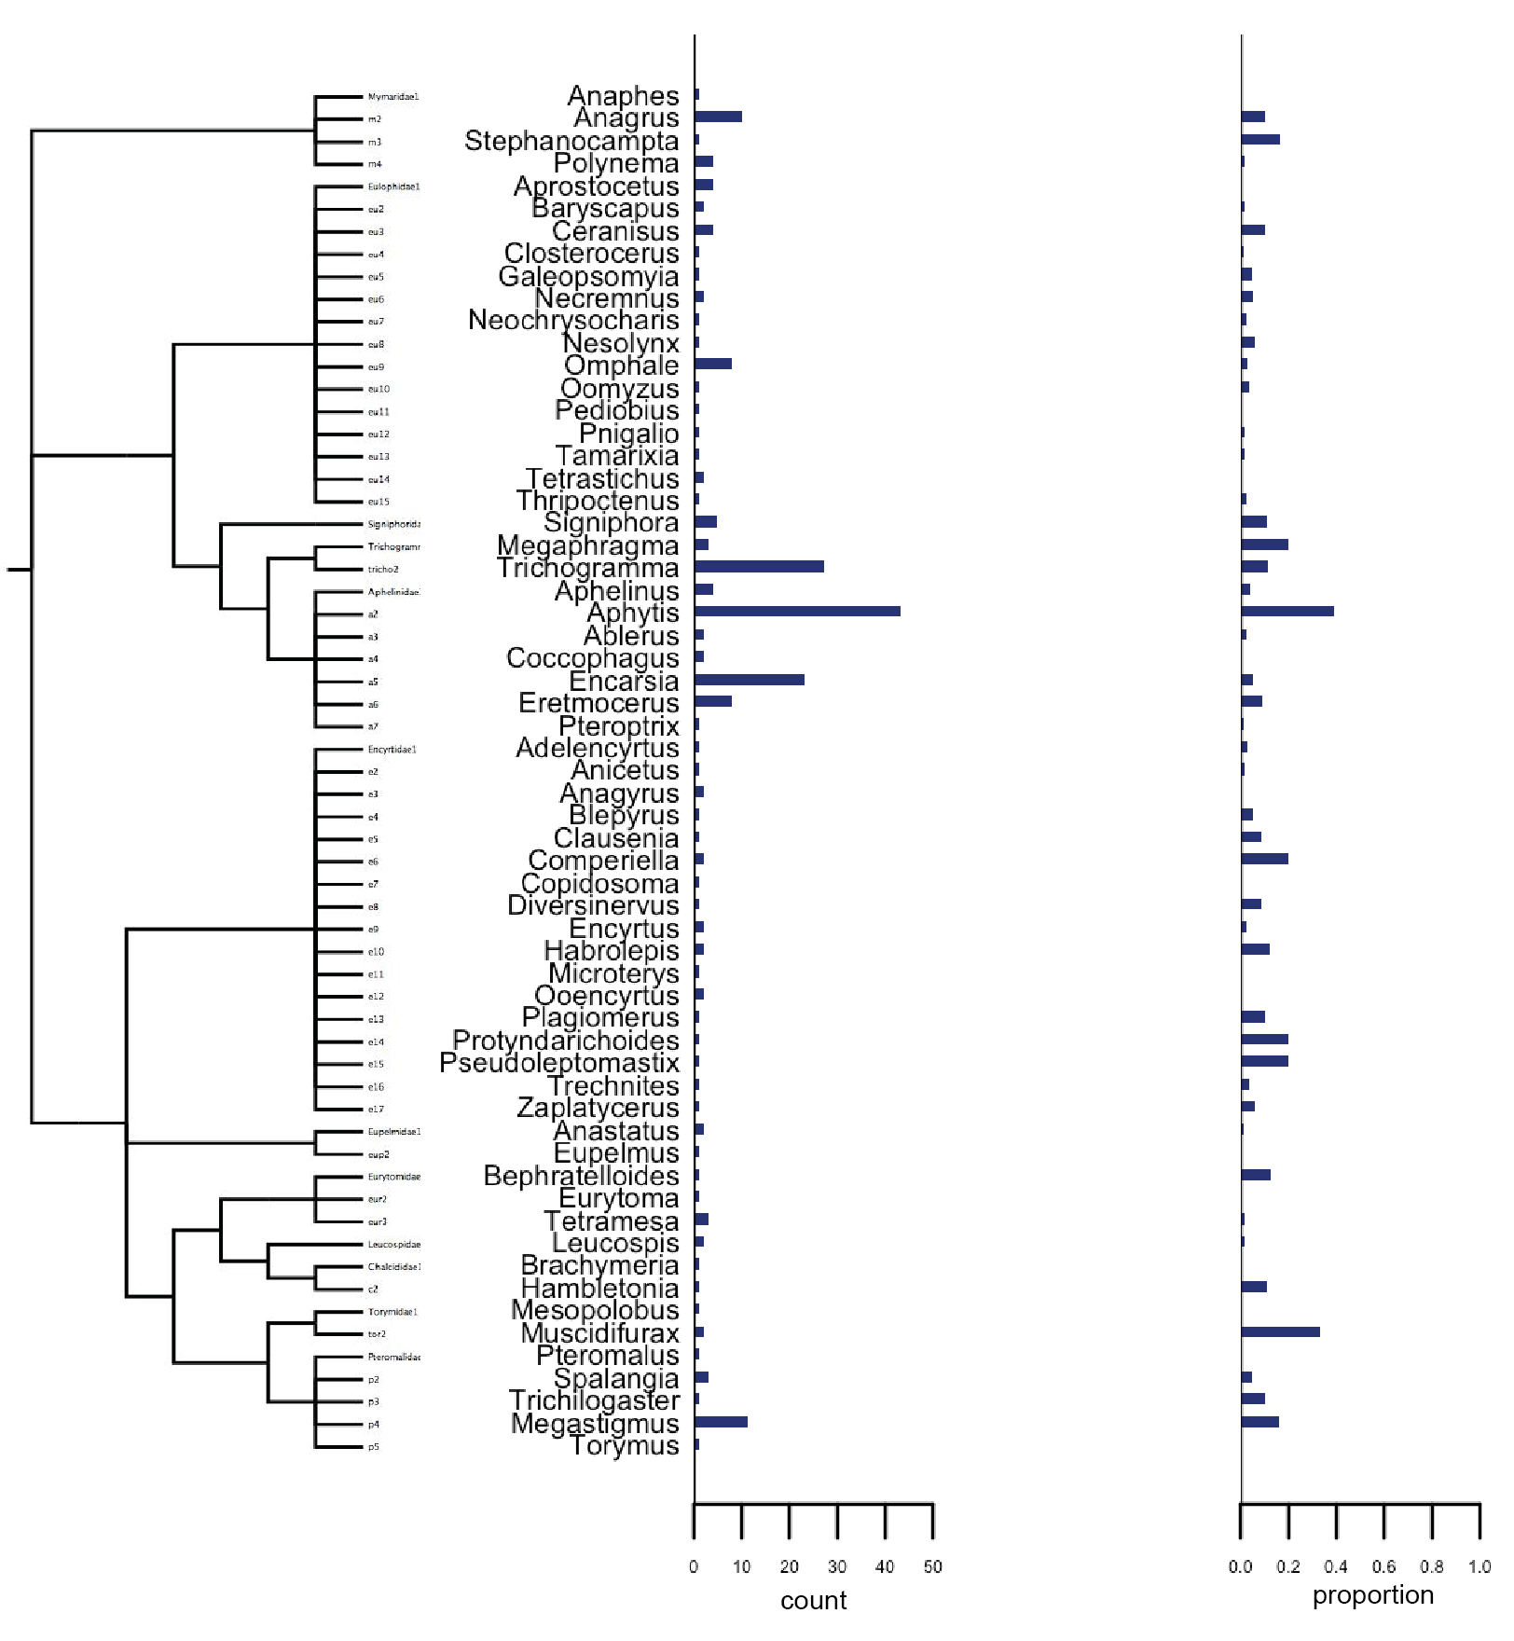

Frequency of parthenogenesis in Chalcidoidea genera. Only genera with at least one case of parthenogenesis found and at least five species described are shown. (not really formatted; to discuss first).

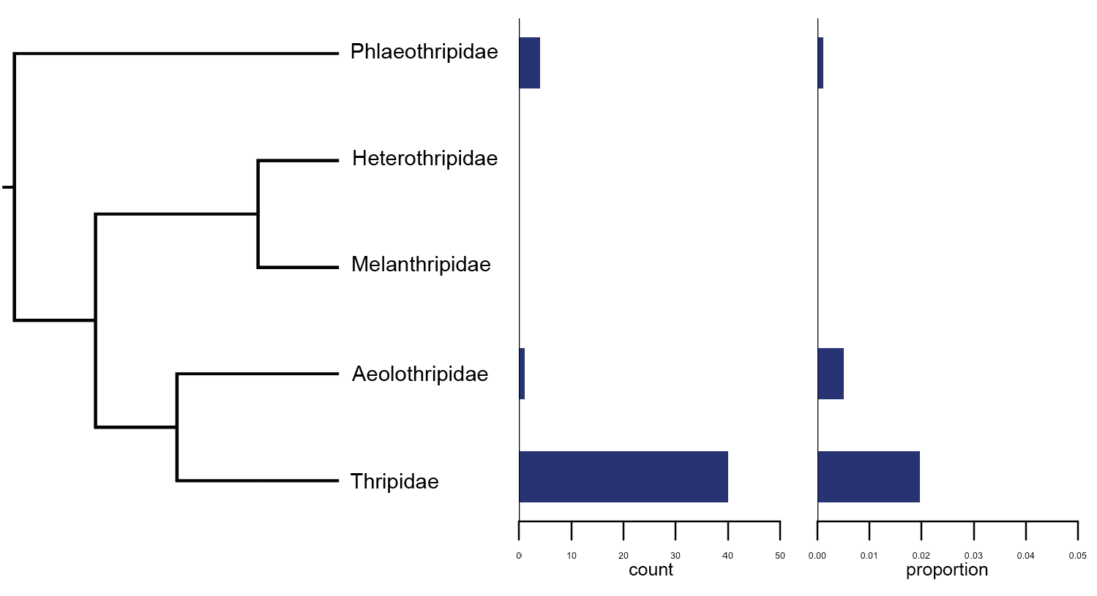

Frequency of parthenogenesis in Thysanoptera. Phylogeny after Buckman et al 2013. Species totals from Mound 2013 - <http://dx.doi.org/10.11646/zootaxa.3703.1.11>. Only extant families with more than 20 species were included (excluding four small families).

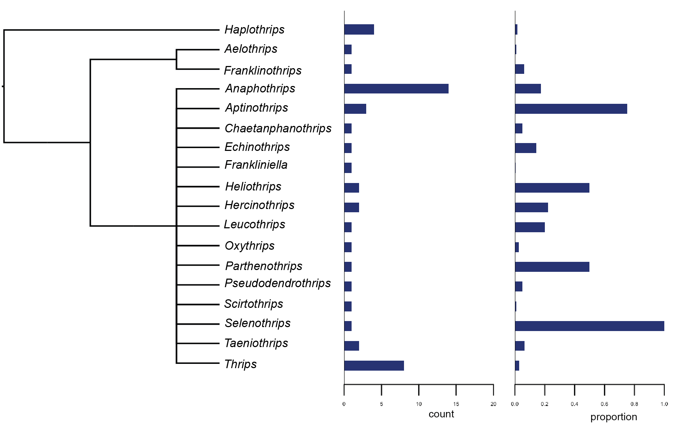Frequency of parthenogenesis Thysanoptera genera. Phylogeny after Buckman et al 2013. Only genera with at least one case of parthenogenesis are shown. Total species number from Mound 2013 - <http://dx.doi.org/10.11646/zootaxa.3703.1.11>.

Table. Frequency of parthenogenesis in Aleyrodoidea. Only genera with at least one case of parthenogenesis described are shown.

|  |  |  |  |  |  |
| --- | --- | --- | --- | --- | --- |
| Taxon | Genus | Cases | Total species | Proportion | Reference species |
| Aleyrodoidae | Total | 4 | 1556 | 0.003 | Whitefly database |
| Aleyrodidae | *Aleurotrachelus* | 1 | 94 | 0.011 | Whitefly database |
| Aleyrodidae | *Aleurotulus* | 1 | 9 | 0.111 | Whitefly database |
| Aleyrodidae | *Parabemisia* | 1 | 8 | 0.125 | Whitefly database |
| Aleyrodidae | *Trialeurodes* | 1 | 87 | 0.011 | Whitefly database |

**Mechanisms of parthenogenesis**



Frequency of endosymbiont-induced parthenogenesis. Total = 142.



Cellular mechanisms of parthenogenesis. Total = 46.

* 119 species are documented to have both sexual and asexual lineages (plus another twenty unsure).

**Polyploid parthenogens**



Frequency of polyploidy in parthenogenetic haplodiploids. The graphs are based only on studies with chromosome counts (left, n=42 vs. 2) and including studies that documented endosymbiont-induced parthenogenesis, hence diploidy was deduced (right, n=114 vs. 2).

**Social systems**

Table.

|  |  |  |  |  |  |  |
| --- | --- | --- | --- | --- | --- | --- |
| pair | superfamily | family | groups | eusocial | cases | species total |
| 1 | Apoidea | Apidae | Euglossini | N | 0 | 300 |
| 1 | Apoidea | Apidae | Meliponini+Apini+Bombini | Y | 3 | 760 |
| 2 | Apoidea | Apidae | Meliponini+Apini+Bombini | Y | 3 | 760 |
| 2 | Apoidea | Apidae | Eucerini+Emphorini+Exomalopsini | N | 0 | >500 |
| 3 | Apoidea | Apidae | Allodapini | Y | 0 | 250 |
| 3 | Apoidea | Apidae | Ceratini | N | 3 | 400 |
| 4 | Apoidea | Crabronidae | Microstigmus | Y | 0 | 31 |
| 4 | Apoidea | Crabronidae | Non-social Crabronidae | N | 0 | 9000 |
| 5 | Apoidea | Halictidae | Halictus + Lasioglossum | Y | 0 | 1568 |
| 5 | Apoidea | Halictidae | Agapostemon | N | 0 | 45 |
| 6 | Apoidea | Halictidae | Augochlorini eusocial | Y | 0 | 525 |
| 6 | Apoidea | Halictidae | Nominae* | N | 0 | 500 |
| 7 | Vespoidea | Formicidae | Formicidae | Y | 33 | 13167 |
| 7 | Apoidea | Apidae | Non-social Apoidea | N | 8 | 20000 |
| 8 | Vespoidea | Vespidae | Stenogastrinae | Y | 0 |  |
| 8 | Vespoidea | Vespidae | Eumeninae | N | 0 |  |
| 9 | Vespoidea | Vespidae | Polistinae+Vespinae | Y | 0 |  |
| 9 | Vespoidea | Vespidae | Eumeninae | N | 1 | 3200 |